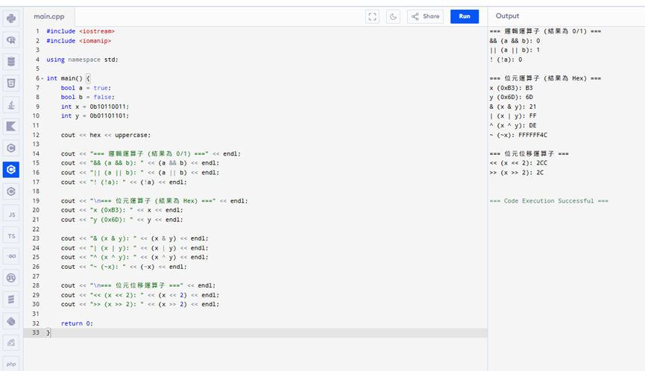

#include <iostream>
#include <iomanip>

using namespace std;

int main() {
bool a = true;
bool b = false;
int x = 0b10110011;
int y = 0b01101101;

cout << hex << uppercase;

cout << "=== 邏輯運算子 (結果為 0/1) ===" << endl;
cout << "&& (a && b): " << (a && b) << endl;
cout << "|| (a || b): " << (a || b) << endl;
cout << "! (!a): " << (!a) << endl;

cout << "\n=== 位元運算子 (結果為 Hex) ===" << endl;
cout << "x (0xB3): " << x << endl;
cout << "y (0x6D): " << y << endl;

cout << "& (x & y): " << (x & y) << endl;
cout << "| (x | y): " << (x | y) << endl;
cout << "^ (x ^ y): " << (x ^ y) << endl;
cout << "~ (~x): " << (~x) << endl;

cout << "\n=== 位元位移運算子 ===" << endl;
cout << "<< (x << 2): " << (x << 2) << endl;
cout << ">> (x >> 2): " << (x >> 2) << endl;

return 0;
}

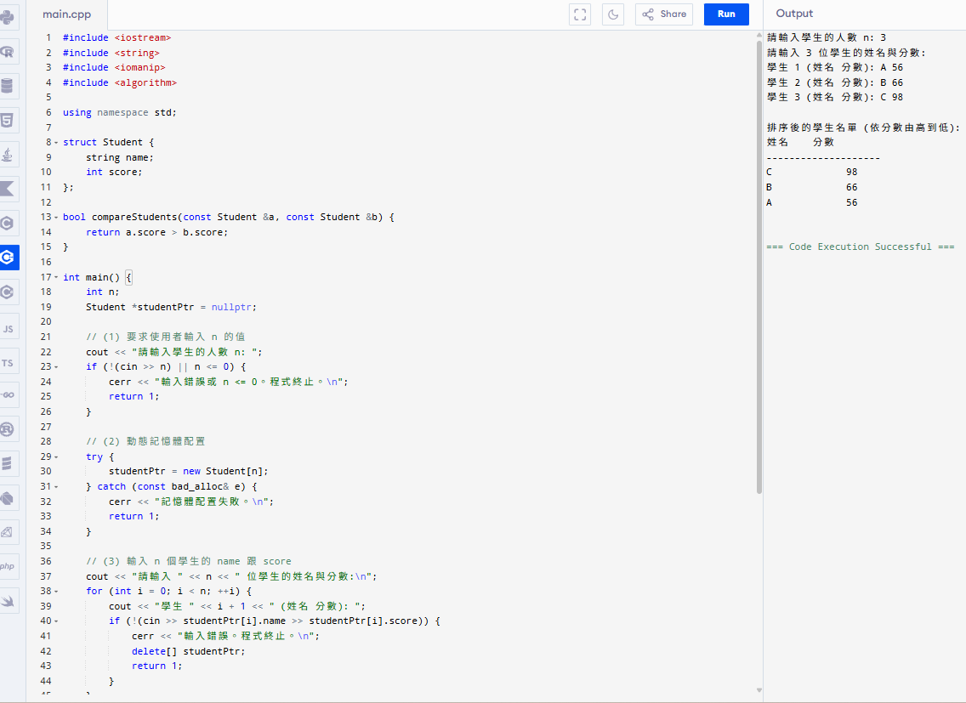

#include <iostream>
#include <string>
#include <iomanip>
#include <algorithm>

using namespace std;

struct Student {
string name;
int score;
};

bool compareStudents(const Student &a, const Student &b) {
return a.score > b.score;
}

int main() {
int n;
Student *studentPtr = nullptr;

// (1) 要求使用者輸入 n 的值
cout << "請輸入學生的人數 n: ";
if (!(cin >> n) || n <= 0) {
cerr << "輸入錯誤或 n <= 0。程式終止。\n";
return 1;
}

// (2) 動態記憶體配置
try {
studentPtr = new Student[n];
} catch (const bad_alloc& e) {
cerr << "記憶體配置失敗。\n";
return 1;
}

// (3) 輸入 n 個學生的 name 跟 score
cout << "請輸入 " << n << " 位學生的姓名與分數:\n";
for (int i = 0; i < n; ++i) {
cout << "學生 " << i + 1 << " (姓名 分數): ";
if (!(cin >> studentPtr[i].name >> studentPtr[i].score)) {
cerr << "輸入錯誤。程式終止。\n";
delete[] studentPtr;
return 1;
}
}

// (4) 排序 (由大到小)
sort(studentPtr, studentPtr + n, compareStudents);

// 輸出結果
cout << "\n排序後的學生名單 (依分數由高到低):\n";
cout << setw(10) << left << "姓名" << setw(6) << right << "分數" << endl;
cout << "--------------------\n";
for (int i = 0; i < n; ++i) {
cout << setw(10) << left << studentPtr[i].name << setw(6) << right << studentPtr[i].score << endl;
}

// 釋放動態配置的記憶體
delete[] studentPtr;
studentPtr = nullptr;

return 0;
}

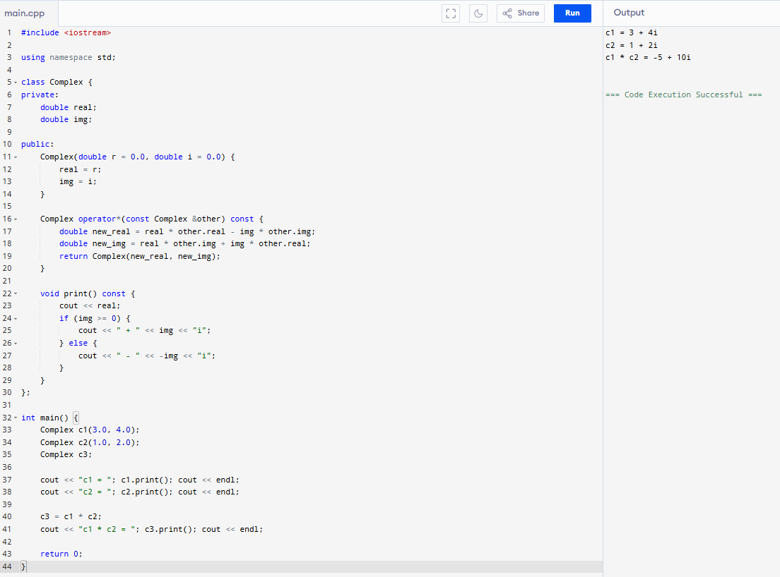
#include <iostream>

using namespace std;

class Complex {
private:
double real;
double img;

public:
Complex(double r = 0.0, double i = 0.0) {
real = r;
img = i;
}

Complex operator*(const Complex &other) const {
double new_real = real * other.real - img * other.img;
double new_img = real * other.img + img * other.real;
return Complex(new_real, new_img);
}

void print() const {
cout << real;
if (img >= 0) {
cout << " + " << img << "i";
} else {
cout << " - " << -img << "i";
}
}
};

int main() {
Complex c1(3.0, 4.0);
Complex c2(1.0, 2.0);
Complex c3;

cout << "c1 = "; c1.print(); cout << endl;
cout << "c2 = "; c2.print(); cout << endl;

c3 = c1 * c2;
cout << "c1 * c2 = "; c3.print(); cout << endl;

return 0;
}

